Structure of a cTRAIN Title

cTRAIN structure:

1. User intro teaches how to use cTRAIN – this in an Account selection (not in Builder). There are 3 options:
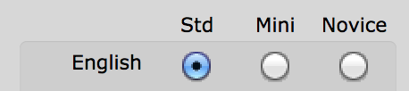
• Std (Standard) is for older adults unfamiliar with online training
• Mini is for people who have grown up with the internet
• Novice is for immigrants with limited English skills or education

You can select one of the User intros, but you cannot change its screens. This choice is made when you are ready to show the title to users (contact NwETA to set the intro and several other functions - eg, exclude menu). These can be changed at any time.

2. Title screen – you can change your title.

3. Menu screen - used if the title has more than one topic and if you want to let trainees decide on the order they complete topics.

4. Topic Overview – this is a required screen.

5. Pre-test - you can elect not to use the pretest, but it will exist and just will not be shown – you can add a survey in the pre-test, limiting it to up to 4-answer questions.
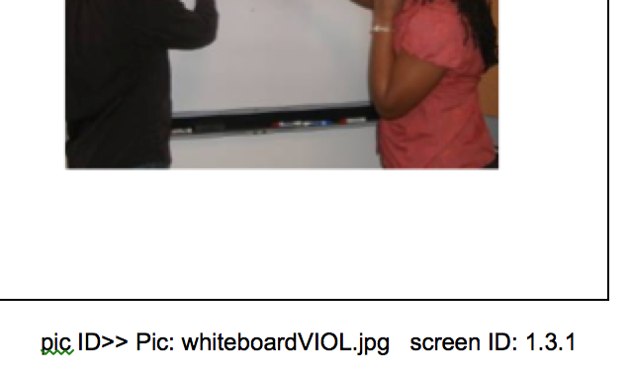
6. The training is divided into “infosets” that end with a test question – if you select the wrong answer you return to the first screen in the infoset. The screen ID is the clue to the infosets: The first infoset begins with the screen ID 1.3.1. The ID of the picture (generally a name) is also on the lower right corner of the screen in word documents – whiteboardVIOL.jpg in the example.

Sometimes developers use OPTIONAL (extraset) screens. Only a few trainees choose an optional screen but it is a great place to add more information that is important for some people but would interrupt the flow of the training for most users – so you can make it optional in that they have to press a specific number to see it.

7. Post-test

